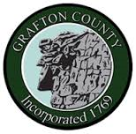
GRAFTON COUNTY ALTERNATIVE SENTENCING
3801 Dartmouth College Highway
North Haverhill, New Hampshire 03774
Phone (603) 787-2042 Fax (603) 787-2044

C.A.R.E Program Referral

Contact Information
Referral Name: DOB:
Address:

Phone #:
Email:

Probation Officer Information
Name:
Email:
Phone #:
Probation Location: Choose an item.
Reason for Referral: Original Charge/Concerns (i.e. drug use, limited community resources, etc)

*** Please include Conditions of Release with Referral Form ***

