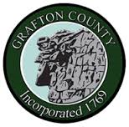
GRAFTON COUNTY ALTERNATIVE SENTENCING
3801 Dartmouth College Highway
North Haverhill, New Hampshire 03774
Phone (603) 787-2042 Fax (603) 787-2044

C.A.R.E+ Program Referral

Contact Information
Referral Name: DOB:
Address:
Phone #:
Email:

Insurance Information
Insurance Provider:
Policy Number:

Transportation (check all that apply):
☐Do you have a license? ☐Do you have a vehicle? ☐Do you have reliable transportation?

Prosecutor Information:
Name:
Email:
Phone #:

Probation:
Are you on Probation? Choose an item. Probation Officer: Choose an item.

Reason for Referral: Original Charge/Concerns

