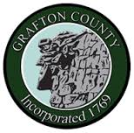
GRAFTON COUNTY ALTERNATIVE SENTENCING
3801 Dartmouth College Highway
North Haverhill, New Hampshire 03774
Phone (603) 787-2042 Fax (603) 787-2044

Juvenile Restorative Justice Referral Form

Referral Information
Name: Date of Referral: Click or tap to enter a date.
Department/Agency:
Address:
Phone #:
Email:

Offender Information
Name:
Address:

Phone #:

Parent/Guardian Information
Name:
Address (if different from offender):

Home #: Cell #: Work #:

Reason for Referral: Original Charge/Concerns (i.e. drug use, limited community resources, etc)

*** Please include Police Report or a Summary ***

