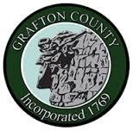
GRAFTON COUNTY ALTERNATIVE SENTENCING
Intimate Partner Domestic Violence Program
3801 Dartmouth College Highway North Haverhill, New Hampshire 03774
Phone (603) 787-2042 Fax (603) 787-2044

GRAFTON COUNTY IPDVP
REFERRAL FORM

Referral Information Date of Referral:

Name: Phone #: E-mail:

Address/Department:

Offender information

Name:

Phone #: _______________________________

DOB: _______________________________

Please Check Below:

Court Ordered

Self-referral

Behavior based

IF COURT ORDERED, PLEASE ATTACH ORDER

Email to Nicole Mitchell, AS@graftoncountynh.gov

